Maths task for Tuesday 19th May 2020

See next page for challenge

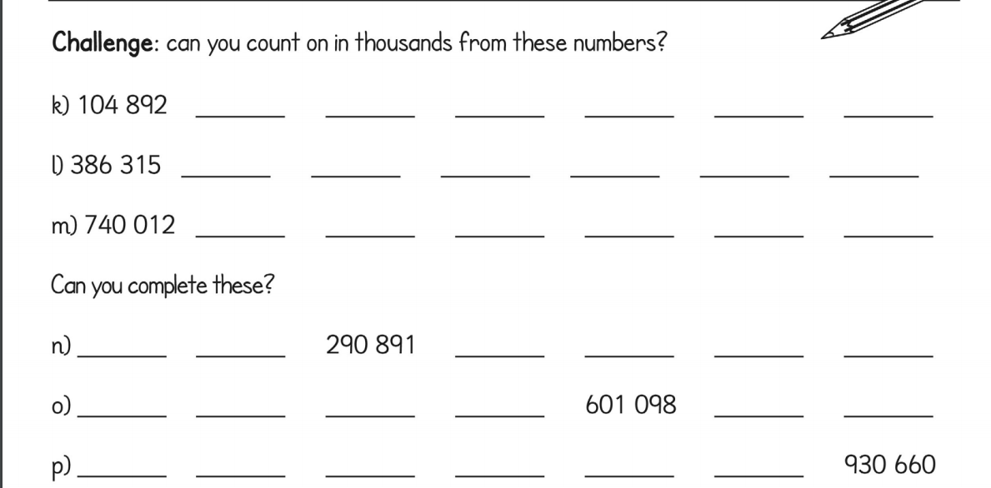

Can you make up your own sequence?
___ ___ ___ ___ ___ ___ ___ ___ ___

___ ___ ___ ___ ___ ___ ___ ___ ___

