Decorate an Egg Competition for
World Book Day
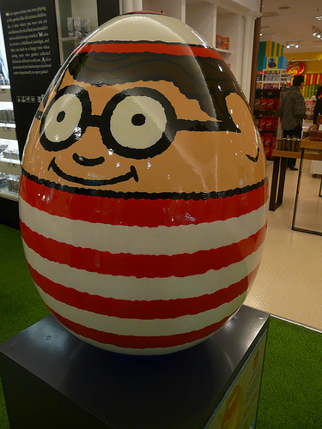
For World Book Day this year we would like you to decorate a hard-boiled egg as your favourite book character.

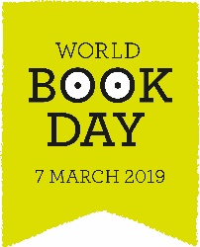
Please bring in your eggcellent entries on Wednesday 4th March, the winners will be announced during a special assembly on Thursday.
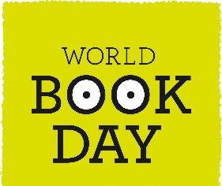
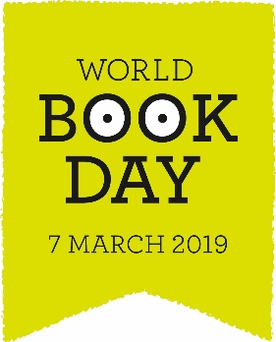
Remember – Your egg will need to have a stand with your name clearly written on.
We are eggcited to see your entries.

Decorate an Egg Competition for
World Book Day

For World Book Day this year we would like you to decorate a hard-boiled egg as your favourite book character.

Please bring in your eggcellent entries on Wednesday 4th March, the winners will be announced during a special assembly on Thursday.
Remember – Your egg will need to have a stand with your name clearly written on.
We are eggcited to see your entries.
World Book Day 5th March
There will be a special morning assembly for children to show off their outfits and find out the winners of the egg competition.
The children will also have the chance to listen to stories by a professional story teller.
As part of World Book Day we would like children to come into school dressed as their favourite book character.

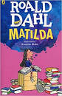
Every child will also receive a World Book Day Token.

World Book Day 5th March
The children will also have the chance to listen to stories by a professional story teller.
There will be a special morning assembly for children to show off their outfits and find out the winners of the egg competition.
As part of World Book Day we would like children to come into school dressed as their favourite book character.
Every child will also receive a World Book Day Token.

